A Simplified Forest Inventory and Analysis Database: FIADB-Lite
Pat Miles
Northern Research Station
pmiles@fs.fed.us
651 649-5146

Contents
Abstract: 2
Introduction 3
FIADB-Lite database structure 5
Downloading FIADB comma-delimited data 7
Importing FIADB into a Microsoft Access database 13
Using the FIADB-Lite database 20
Per acre estimate examples: 20
Population estimate examples: 23
Appendix A – PLOTSNAP table description 27
Appendix B – Example Oracle SQL scripts for generating population estimates 33

Abstract:
FIADB-Lite was developed to simplify the generation of forest statistics using USFS Forest Inventory and Analysis Program (FIA) data. FIADB-Lite data can be loaded into any relational database to generate estimates of forest area and tree biomass, volume, growth, removals and mortality. FIADB-Lite consists of 4 tables (POP_EVAL_GRP, COND, TREE) that are described in detail in the FIADB Users Guide (Conkling editor, draft) and one new table (PLOTSNAP).

The PLOTSNAP table combines information from three FIADB tables (PLOT, POP_EVAL_GRP and POP_STRATUM) to provide a “snapshot” of the PLOT records and their associated expansion and adjustment factors that were used to produce a State inventory report. Combining information from these three tables greatly simplifies the procedures for generating forest statistics. Users needing associated sampling errors should use the entire FIADB rather than FIADB-Lite since calculation of variances and sampling errors requires information from additional tables.

FIADB-Lite download files and an MS-Access database with stored Data Import Specifications and stored Queries for generating population estimates are available from the FIA national website (www.fia.fs.fed.us) on the data download page. Example SQL scripts for Oracle database users are in Appendix B.

Introduction

This document is meant to be a companion publication to the FIADB Users Guide Version 3.0 (Conkling editor, draft). The FIADB (Forest Inventory and Analysis Data Base) format contains all the information needed to produce population estimates and their associated sampling errors. Some FIA data users, however, may not be interested in sampling errors, or, for that matter, population estimates. These users will find the FIADB unnecessarily complex.

GIS specialists, for example, may only be interested in identifying and retrieving geographic information and per acre values for the set of plots used in producing forest statistics for a State report. To identify this set of plots using the FIADB the user must join records from 6 tables (POP_EVAL_GRP POP_EVAL, POP_ESTN_UNIT, POP_STRATUM, POP_PLOT_STRATUM_ASSGN, and PLOT).

Application developers and modelers may also find the FIADB to be overly complex. While this level of complexity is required for computing sampling errors it is not necessary for computing population estimates. Much of the complexity can be stripped away if sampling errors are not needed.

FIADB-Lite was designed for these users. The set of plots used in producing forest statistics for a State report can be identified via a single variable (EVAL_GRP) found on the PLOTSNAP table. Data processing has also been simplified by combining information found in 3 tables (PLOT, POP_EVAL_GRP and POP_STRATUM) into a single table (PLOTSNAP).

Examples for generating population estimates from the FIADB-Lite format are written in the Structured Query Language (SQL) for Microsoft Access and Oracle.

FIADB-Lite database structure

The FIADB-Lite database consists of 5 tables. A brief description of the 5 FIADB-Lite tables is provided in Table 1. Four of these tables (POP_EVAL_GRP, COND, TREE and SEEDLING) replicate tables from the FIADB. These 4 FIADB tables are fully documented elsewhere (Conkling editor, draft). The fifth table (PLOTSNAP) combines data found in FIADB tables PLOT, POP_EVAL_GRP, and POP_STRATUM. A comprehensive description for the PLOTSNAP table is provided in Appendix A.

Table 1. FIADB-Lite table descriptions.
Table Name | Description
POP_EVAL_GRP | Each record in the POP_EVAL_GRP table corresponds to a state inventory report. For example, there are currently 6 POP_EVAL_GRP records for the State of Michigan:  1) the 1980 periodic inventory,  2) the 1993 periodic inventory,  3) the 2000-2003 rolling average annual inventory,  4) the 2000-2004 rolling average annual inventory,  5) the 2001-2005 rolling average annual inventory, and  6) the 2002-2006 rolling average annual inventory  Each of these inventories can be uniquely identified in the POP_EVAL_GRP table by two variables (STATECD and EVAL_GRP).
PLOTSNAP | Provides information relevant to the entire 1-acre field plot. Similar to the PLOT table in the FIADB except that it includes an EVAL_GRP variable allowing the PLOTSNAP record to be directly linked to the corresponding record in the POP_EVAL_GRP table. The PLOTSNAP table also contains expansion and adjustment factors to identify the number of acres the sample plot represented in the state inventory for area, volume, growth, removals, and mortality.
COND | Provides information on the discrete combination of landscape attributes that define the condition (a condition will have the same land class, reserved status, owner group, forest type, stand-size class, regeneration status, and stand density). Can be  linked to plot record where cond.plt_cn=plot.cn.
TREE | Describes each tree (1 inch in diameter and larger) found on a microplot or subplot. Can be linked to plot record where tree.plt_cn=plot.cn.
SEEDLING | Provides a count of the number of live trees of a species found on a  microplot that are less than 1 inch in diameter but at least 6 inches in length for conifer species or at least 12 inches in length for hardwood species. Can be linked to plot record where seedling.plt_cn=plot.cn.

Downloading FIADB comma-delimited data

Currently FIADB download files can be found at: http://199.128.173.26/fiadb-downloads/fiadb3.html. There are now fifty-eight tables available for downloading on this webpage. Seventeen of these tables are reference or lookup tables containing information about the meaning of various numeric codes in the database. The other forty-one tables contain FIA data (field data, summarized remote sensing data, and computed data). These forty-one tables are bundled by State into a ZIP file. The five FIADB-Lite tables (POP_EVAL_GRP, PLOTSNAP, COND, TREE, and SEEDLING) are included in each State bundle. It is easier to retrieve a State ZIP file containing all 41 tables then it would be to retrieve the five tables individually.

There are six steps involved in downloading comma-delimited data. In this example the State Zip file for Rhode Island will be downloaded.

Step 1) Go to the FIADB download webpage at http://199.128.173.26/fiadb-downloads/fiadb3.html and click on the State abbreviation “RI” on the map on the left side of the page (Fig. 1).
Note: Microsoft Access database users interested in data for only a single state can simply download a fully populated Microsoft Access database by clicking on the State of interest on the map on the right side of the page. These Microsoft Access tables include all of the FIADB tables, the PLOTSNAP table, and example SQL queries.
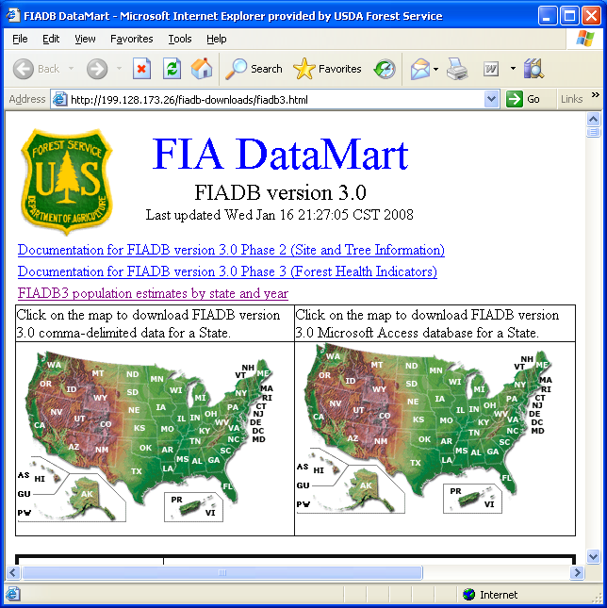
Figure 1. Clickable map for downloading FIA data by State.

Step 2) A File Download window (Fig. 2) will appear on your screen. Click on the “Save” button.

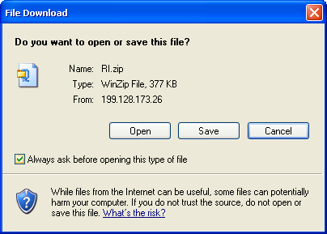
Figure 2. File Download window.

Step 3) Save the file “RI.zip” in a folder called RI on your computer. In this example the folder was saved at the root directory (C:\).

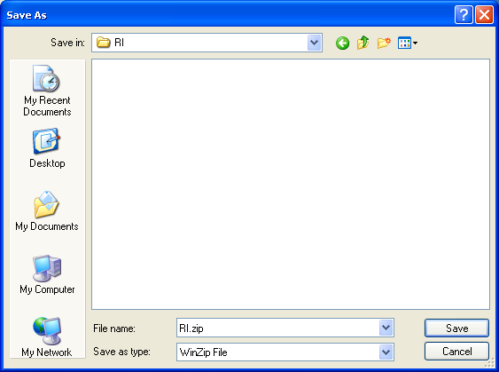
Figure 3. Save the RI.zip file.

Step 4) Double-click on the RI.zip file (Fig.4) to begin extracting the data files within.
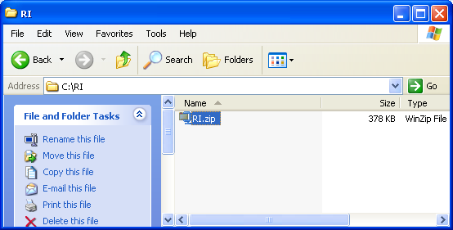

Figure 4. Double-click on RI.zip icon to begin extracting data from zip file.

Step 5) Click on the Extract button (Fig. 5) to begin extracting all the files in the zip.

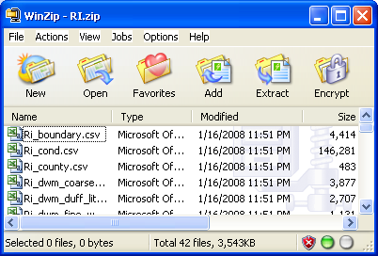
Figure 5. Click on “Extract” button.

Step 6) The Extract window (Fig. 6) will open. Specify the folder where you want the data files to go and click on the “Extract” button. In this case we want to save the files in C:\RI.
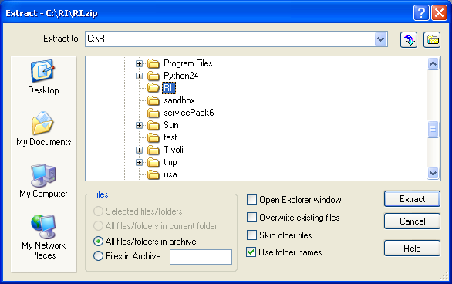
Figure 6. Extract window.

The files should now be in the folder C:\RI.

Importing FIADB data into a Microsoft Access database

The following steps require the user to have Microsoft Access software on their computers.

An MS-Access database file named Shell_FIADB_Lite.mdb is available for downloading at http://199.128.173.26/fiadb-downloads/fiadb3.html. Click on the link labeled Microsoft Access Database file ready for loading FIADB-Lite data (empty, pre-defined tables, ready to import data) to download this file to your computer. Save this file in folder C:\RI.

The Shell_FIADB_Lite.mdb database contains 5 empty Tables, 5 Data Import Specifications, and over 40 Queries for generating population estimates and per acre values. The 5 tables in the database are initially empty. Data from one or more States can be imported into the database to populate these 5 tables. Microsoft Access files cannot exceed 2 gigabytes so only a few States can be loaded into the Shell_FIADB_Lite database at one time. The following example illustrates how to populate the Shell_FIADB_Lite database.

Open the Shell_FIADB_LITE database by double-clicking on double-click on the file into directory C:\RI, double-click on the filename “Shell_FIADB_LITE.mdb”. The Microsoft Access database will open. There will be 5 empty tables in this database (Fig. 7): COND, PLOTSNAP, POP_EVAL_GRP, SEEDLING, and TREE.

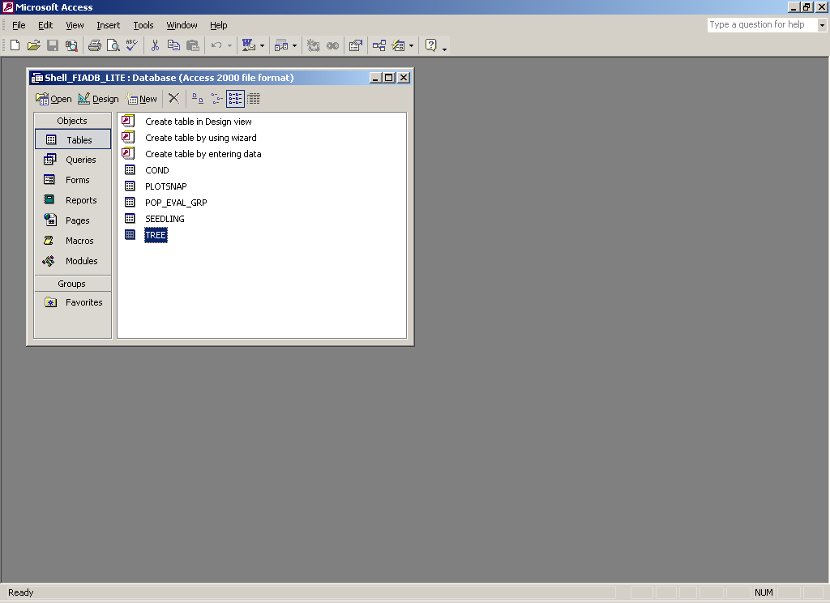
Figure 7. Five empty tables in Shell_FIADB_LITE database.

The database also has over 40 queries (Fig. 8) that can be used to generate population estimates and per acre values.

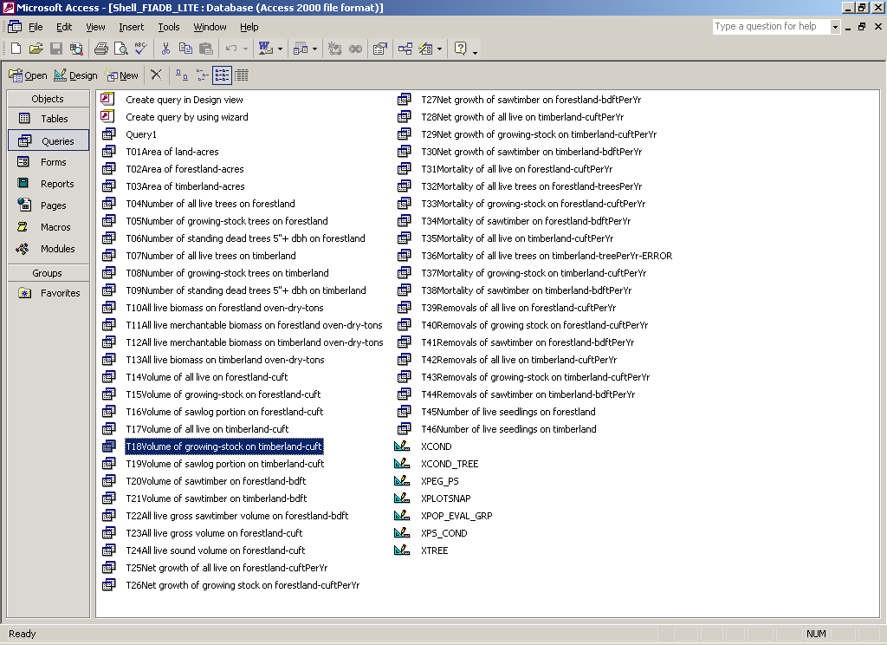
Figure 8. Queries available in Shell_FIADB_LITE database.

Import specification files have also been created to facilitate the loading of the CSV files you have extracted. There are seven steps to importing the comma-delimited data into the Shell_FIADB_LITE database.

Step 1) Open the Shell_FIADB_LITE database and click on “Forms” (Fig. 9). Then double-click on “Import FIADB-Lite Data for a State”.
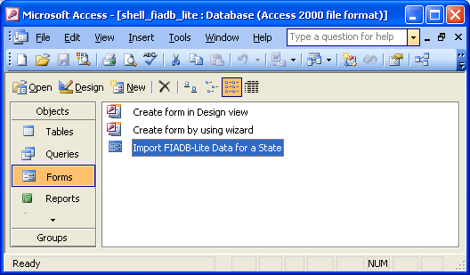

Figure 9. Access form to load FIADB-Lite data into Access tables.

Step 2) A form will appear with one command button: “Click me to find extracted PLOTSNAP FILE and import all FIADB-Lite data” (Fig. 10). Click on this command button.

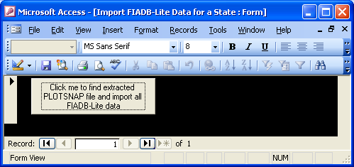

Figure 10.

Step 3) A common dialog window will appear. Locate the RI_PLOTSNAP.CSV file and double-click on the filename. If the import is successful a message box should appear (Fig. 11). Click on the “OK” button (Fig. 12) and close the form.

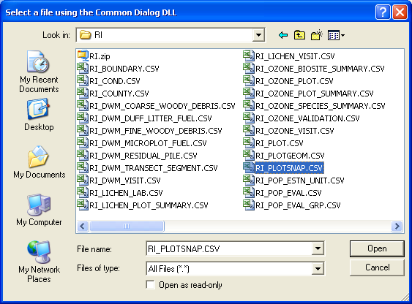

Figure 11. Use this common dialog window to navigate to C:\RI\RI_PLOTSNAP.CSV



Figure 12. Message box indicating that the import was successful.

Step 4) Then go to “Tables” and double-click on “COND” (Fig. 13).

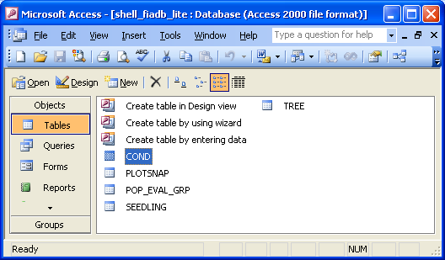

Figure 13. COND table.

There should now be records in the COND table (Fig. 14 )

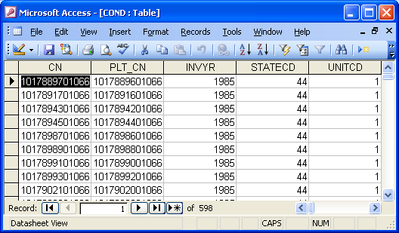

Figure 14. COND table records.

Using the FIADB-Lite database

Appendix B contains a listing of the population estimates and associated Oracle SQL scripts that can be computed using the FIADB-Lite. Several examples of both Oracle and MS-Access SQL scripts are provided here.

Not all estimates can be produced for every state/inventory. Estimates of biomass, numbers of trees, volume, growth, removals, and mortality on forestland will usually be unavailable for inventories conducted prior to 1999 (prior to implementation of the annual inventory sample design). For these earlier inventories tree measurements were taken on timberland plots but not always on unproductive and reserved forestland plots. A spreadsheet providing “FIADB3 population estimates by state and year” is available at http://199.128.173.26/fiadb-downloads/FIADB3_pop_estimates.html. This spreadsheet provides 46 population estimates for each state/inventory as derived from version 3 of the FIADB. A value of zero for any estimate indicates that the inventory should not be used to calculate this estimate for the indicated state/inventory.

Per acre estimate examples:
Proportion of plot that is forest land, Alabama 2006.
Oracle SQL | select p.cn, p.lat, p.lon, sum(c.condprop_unadj) prop_forestland  from pop_eval_grp peg, plotsnap p, cond c  where c.cond_status_cd = 1  and p.cn = c.plt_cn  and peg.eval_grp = p.eval_grp  and peg.statecd = p.statecd  and peg.statecd = 1  and peg.eval_grp = 12006  group by p.cn, p.lat, p.lon;
MS-Access SQL | SELECT PLOTSNAP.CN, First(PLOTSNAP.LAT) AS LAT, First(PLOTSNAP.LON) AS LON, Sum(COND.CONDPROP_UNADJ) AS [Proportion forestland]  FROM POP_EVAL_GRP INNER JOIN (PLOTSNAP INNER JOIN COND ON PLOTSNAP.CN=COND.PLT_CN) ON POP_EVAL_GRP.CN=PLOTSNAP.EVAL_GRP_CN  WHERE COND.COND_STATUS_CD=1 AND POP_EVAL_GRP.EVAL_GRP=12006 AND POP_EVAL_GRP.STATECD=1  GROUP BY PLOTSNAP.CN;
Output
  CN | LAT | LON | PROP_FORESTLAND
  22346696010478 | 34.033407 | -87.822223 | 1
  22346469010478 | 34.930357 | -86.593645 | 0.4917
  81668124010478 | 34.341840 | -88.080651 | 1
  81668064010478 | 34.561975 | -88.023739 | 1
  … | … | … | …

Live tree biomass per acre by forest land plot, Alabama 2006 (dry tons).
Oracle SQL | select p.cn,p.lat,p.lon,  sum(t.tpa_unadj * t.drybiot / 2000 ) dryTonsPerAcre  from pop_eval_grp peg, plotsnap p, cond c, tree t  where t.plt_cn = c.plt_cn  and t.condid = c.condid  and c.cond_status_cd = 1  and t.statuscd = 1  and p.cn = c.plt_cn  and peg.eval_grp = p.eval_grp  and peg.statecd = p.statecd  and peg.statecd = 1 and peg.eval_grp = 12006  group by p.cn,p.lat,p.lon;
MS-Access SQL | SELECT PLOTSNAP.CN, First(PLOTSNAP.LAT) AS LAT, First(PLOTSNAP.LON) AS LON, Sum([DRYBIOT]/2000*[TPA_UNADJ]) AS DryTonsPerAcre  FROM POP_EVAL_GRP INNER JOIN ((PLOTSNAP INNER JOIN COND ON PLOTSNAP.CN = COND.PLT_CN) INNER JOIN TREE ON (COND.CONDID = TREE.CONDID) AND (COND.PLT_CN = TREE.PLT_CN)) ON POP_EVAL_GRP.CN = PLOTSNAP.EVAL_GRP_CN  WHERE POP_EVAL_GRP.STATECD=1 AND POP_EVAL_GRP.EVAL_GRP=12006 AND COND.COND_STATUS_CD=1 AND TREE.STATUSCD=1  GROUP BY PLOTSNAP.CN;
Output
  CN | LAT | LON | DRYTONSPERACRE
  22346696010478 | 34.033407 | -87.822223 | 35.65785678
  22346469010478 | 34.930357 | -86.593645 | 72.87423088
  81668124010478 | 34.341840 | -88.080651 | 46.33913154
  81668064010478 | 34.561975 | -88.023739 | 2.568083244
  … | … | … | …

Population estimate examples:
Forest land area 2006 inventory of Alabama.
Oracle SQL | select g.eval_grp_descr, sum(expcurr * condprop_unadj * adj_expcurr) acres  from plotsnap p, cond c, pop_eval_grp g  where c.cond_status_cd = 1  and c.plt_cn = p.cn  and p.eval_grp = g.eval_grp  and p.statecd = g.statecd  and p.eval_grp = 12006  and p.statecd = 1  group by g.eval_grp_descr
MS-Access SQL | SELECT POP_EVAL_GRP.EVAL_GRP_DESCR,  Sum([EXPCURR]*[CONDPROP_UNADJ]*[ADJ_EXPCURR])  AS [Area of forestland-acres]  FROM POP_EVAL_GRP INNER JOIN  (PLOTSNAP INNER JOIN COND ON PLOTSNAP.CN = COND.PLT_CN)  ON POP_EVAL_GRP.CN = PLOTSNAP.EVAL_GRP_CN  WHERE PLOTSNAP.STATECD=1  AND PLOTSNAP.EVAL_GRP=12006  AND COND.COND_STATUS_CD=1  GROUP BY POP_EVAL_GRP.EVAL_GRP_DESCR;
Output
  EVAL_GRP_DESCR | ACRES
  Alabama: 2001-2006: Annual - Moving Avg - 9th Survey 1 panel (4) + 8th Survey | 22566073.34

Volume of growing-stock on timberland 2006 inventory of Alabama.
Oracle SQL | select peg.eval_grp_descr,  sum(t.tpa_unadj * t.volcfnet * expvol *  decode(dia,null,adj_expvol_subp,  decode(least(dia,5-0.001),dia,adj_expvol_micr,  decode(least(dia,  nvl(MACRO_BREAKPOINT_DIA,9999)-0.001),  dia,adj_expvol_subp,  adj_expvol_macr)))) CUFT  from pop_eval_grp peg, plotsnap p, cond c, tree t  where t.plt_cn = c.plt_cn  and t.condid = c.condid  and c.cond_status_cd = 1  and c.reservcd = 0  and c.siteclcd in (1, 2, 3, 4, 5, 6)  and t.statuscd = 1  and t.treeclcd = 2  and p.cn = c.plt_cn  and peg.eval_grp = p.eval_grp  and peg.statecd = p.statecd  and peg.statecd = 1 and peg.eval_grp = 12006  group by peg.eval_grp_descr;
MS-Access SQL | SELECT POP_EVAL_GRP.EVAL_GRP_DESCR, Sum([EXPVOL]*[VOLCFNET]*[TPA_UNADJ]*  IIf(IsNull([dia]),[adj_expvol_subp],  IIf([dia]<5,[adj_expvol_micr],  IIf(IsNull([MACRO_BREAKPOINT_DIA]),[adj_expvol_subp],  IIf([dia]<[MACRO_BREAKPOINT_DIA],[adj_expvol_subp],[adj_expvol_macr]))))) AS [Volume of growing-stock on timberland-cuft]  FROM POP_EVAL_GRP INNER  JOIN ((PLOTSNAP INNER JOIN COND ON PLOTSNAP.CN = COND.PLT_CN) INNER JOIN TREE ON (COND.PLT_CN = TREE.PLT_CN) AND (COND.CONDID = TREE.CONDID)) ON POP_EVAL_GRP.CN = PLOTSNAP.EVAL_GRP_CN  WHERE (((TREE.TREECLCD)=2) AND ((COND.COND_STATUS_CD)=1) AND ((TREE.STATUSCD)=1) AND ((COND.RESERVCD)=0) AND ((COND.SITECLCD)=1 Or (COND.SITECLCD)=2 Or (COND.SITECLCD)=3 Or (COND.SITECLCD)=4 Or (COND.SITECLCD)=5 Or (COND.SITECLCD)=6))  GROUP BY POP_EVAL_GRP.EVAL_GRP_DESCR;
Output
  EVAL_GRP_DESCR | CUFT
  Alabama: 2001-2006: Annual - Moving Avg - 9th Survey 1 panel (4) + 8th Survey | 28450849601

Appendix A – PLOTSNAP table description

The PLOTSNAP table was created to simplify the FIADB for users who want an easier way to generate population estimates and are not concerned with determining associated sampling errors. The PLOTSNAP table combines all of the information in the PLOT table with information in the POP_EVAL_GRP table and the POP_STRATUM table to provide a snapshot of the plot records with their associated expansion and adjustment factors used for each State inventory report. There are 74 variables in the PLOTSNAP table. The first 52 variables came from the FIADB PLOT table. The last 22 variables came from the FIADB POP_EVAL_GRP and POP_STRATUM tables.

 | Column name | Oracle Data Type | FIADB table.variable where data was obtained
1 | CN | VARCHAR2(34) | PLOT.CN
2 | SRV_CN | VARCHAR2(34) | PLOT.SRV_CN
3 | CTY_CN | VARCHAR2(34) | PLOT.CTY_CN
4 | PREV_PLT_CN | VARCHAR2(34) | PLOT.PREV_PLT_CN
5 | INVYR | NUMBER(4) | PLOT.INVYR
6 | STATECD | NUMBER(4) | PLOT.STATECD
7 | UNITCD | NUMBER(2) | PLOT.UNITCD
8 | COUNTYCD | NUMBER(3) | PLOT.COUNTYCD
9 | PLOT | NUMBER(5) | PLOT.PLOT
10 | PLOT_STATUS_CD | NUMBER(1) | PLOT.PLOT_STATUS_CD
11 | PLOT_NONSAMPLE_REASN_CD | NUMBER(2) | PLOT.PLOT_NONSAMPLE_REASN_CD
12 | MEASYEAR | NUMBER(4) | PLOT.MEASYEAR
13 | MEASMON | NUMBER(2) | PLOT.MEASMON
14 | MEASDAY | NUMBER(2) | PLOT.MEASDAY
15 | REMPER | NUMBER(3,1) | PLOT.REMPER
16 | KINDCD | NUMBER(2) | PLOT.KINDCD
17 | DESIGNCD | NUMBER(4) | PLOT.DESIGNCD
18 | RDDISTCD | NUMBER(2) | PLOT.RDDISTCD
19 | WATERCD | NUMBER(2) | PLOT.WATERCD
20 | LAT | NUMBER(8,6) | PLOT.LAT
21 | LON | NUMBER(9,6) | PLOT.LON
22 | ELEV | NUMBER(5) | PLOT.ELEV
23 | GROWCD | NUMBER(2) | PLOT.GROWCD
24 | MORTCD | NUMBER(2) | PLOT.MORTCD
25 | P2PANEL | NUMBER(2) | PLOT.P2PANEL
26 | P3PANEL | NUMBER(2) | PLOT.P3PANEL
27 | ECOSUBCD | VARCHAR2(7) | PLOT.ECOSUBCD
28 | CONGCD | NUMBER(4) | PLOT.CONGCD
29 | MANUAL | NUMBER(31) | PLOT.MANUAL
30 | SUBPANEL | NUMBER(2) | PLOT.SUBPANEL
31 | KINDCD_NC | NUMBER(2) | PLOT.KINDCD_NC
32 | QA_STATUS | NUMBER(1) | PLOT.QA_STATUS
33 | CREW_TYPE | NUMBER(1) | PLOT.CREW_TYPE
34 | MANUAL_DB | NUMBER(31) | PLOT.MANUAL_DB
35 | CREATED_BY | VARCHAR2(30) | PLOT.CREATED_BY
36 | CREATED_DATE | DATE | PLOT.CREATED_DATE
37 | CREATED_IN_INSTANCE | NUMBER(6) | PLOT.CREATED_IN_INSTANCE
38 | MODIFIED_BY | VARCHAR2(30) | PLOT.MODIFIED_BY
39 | MODIFIED_DATE | DATE | PLOT.MODIFIED_DATE
40 | MODIFIED_IN_INSTANCE | NUMBER(6) | PLOT.MODIFIED_IN_INSTANCE
41 | MICROPLOT_LOC | VARCHAR2(12) | PLOT.MICROPLOT_LOC
42 | DECLINATION | NUMBER(41) | PLOT.DECLINATION
43 | EMAP_HEX | NUMBER(7) | PLOT.EMAP_HEX
44 | REPLACED_PLOT_NBR | NUMBER(5) | PLOT.REPLACED_PLOT_NBR
45 | SAMP_METHOD_CD | NUMBER(1) | PLOT.SAMP_METHOD_CD
46 | SUBP_EXAMINE_CD | NUMBER(1) | PLOT.SUBP_EXAMINE_CD
47 | MACRO_BREAKPOINT_DIA | NUMBER(2) | PLOT.MACRO_BREAKPOINT_DIA
48 | LAST_INVYR_MEASURED | NUMBER(4) | PLOT.LAST_INVYR_MEASURED
49 | CYCLE | NUMBER(2) | PLOT.CYCLE
50 | SUBCYCLE | NUMBER(2) | PLOT.SUBCYCLE
51 | ECO_UNIT_PNW | VARCHAR2(10) | PLOT.ECO_UNIT_PNW
52 | TOPO_POSITION_PNW | VARCHAR2(2) | PLOT.TOPO_POSITION_PNW
53 | EVAL_GRP_CN | VARCHAR2(34) | POP_EVAL_GRP.CN
54 | EVAL_GRP | NUMBER(6) | POP_EVAL_GRP.EVAL_GRP
55 | EXPALL | NUMBER(13,4) | POP_STRATUM.EXPNS
56 | EXPCURR | NUMBER(13,4) | POP_STRATUM.EXPNS
57 | EXPVOL | NUMBER(13,4) | POP_STRATUM.EXPNS
58 | EXPGROW | NUMBER(13,4) | POP_STRATUM.EXPNS
59 | EXPMORT | NUMBER(13,4) | POP_STRATUM.EXPNS
60 | EXPREMV | NUMBER(13,4) | POP_STRATUM.EXPNS
61 | ADJ_EXPALL | NUMBER(5,4) | POP_STRATUM.ADJ_MACR if value of COND.PROP_BASIS equals ‘MACR’ else from  POP_STRATUM.ADJ_SUBP
62 | ADJ_EXPCURR | NUMBER(5,4) | POP_STRATUM.ADJ_MACR if value of COND.PROP_BASIS equals ‘MACR’ else from  POP_STRATUM.ADJ_SUBP
63 | ADJ_EXPVOL_MACR | NUMBER(5,4) | POP_STRATUM.ADJ_FACTOR_MACR
64 | ADJ_EXPVOL_SUBP | NUMBER(5,4) | POP_STRATUM.ADJ_FACTOR_SUBP
65 | ADJ_EXPVOL_MICR | NUMBER(5,4) | POP_STRATUM.ADJ_FACTOR_MICR
66 | ADJ_EXPGROW_MACR | NUMBER(5,4) | POP_STRATUM.ADJ_FACTOR_MACR
67 | ADJ_EXPGROW_SUBP | NUMBER(5,4) | POP_STRATUM.ADJ_FACTOR_SUBP
68 | ADJ_EXPGROW_MICR | NUMBER(5,4) | POP_STRATUM.ADJ_FACTOR_MICR
69 | ADJ_EXPMORT_MACR | NUMBER(5,4) | POP_STRATUM.ADJ_FACTOR_MACR
70 | ADJ_EXPMORT_SUBP | NUMBER(5,4) | POP_STRATUM.ADJ_FACTOR_SUBP
71 | ADJ_EXPMORT_MICR | NUMBER(5,4) | POP_STRATUM.ADJ_FACTOR_MICR
72 | ADJ_EXPREMV_MACR | NUMBER(5,4) | POP_STRATUM.ADJ_FACTOR_MACR
73 | ADJ_EXPREMV_SUBP | NUMBER(5,4) | POP_STRATUM.ADJ_FACTOR_SUBP
74 | ADJ_EXPREMV_MICR | NUMBER(5,4) | POP_STRATUM.ADJ_FACTOR_MICR

Variable definitions for the first 52 PLOTSNAP variables can be found in the FIADB 3.0 Users Guide.
53. EVAL_GRP_CN Evaluation group sequence number. Foreign key linking the PLOTSNAP record to a unique POP_EVAL_GRP record.
54. EVAL_GRP Evaluation group A variable that in conjunction with the statecd variable uniquely identifies a unique POP_EVAL_GRP record.
55. EXPALL Area expansion factor for all land. The number of acres the sample plot represents for estimating current land area, where the sample includes denied-access and hazardous plots, but excludes outside-of-the-population plots.
56. EXPCURR Area expansion factor for forest and timberland. The number of acres the sample plot represents for estimating current forest and timberland area, where the sample excludes outside-of-the-population, denied-access, and hazardous plots.
57. EXPVOL Volume expansion factor for forest and timberland. The number of acres the sample plot represents for estimating current volume, biomass, and number of trees (based on number of sampled plots only).
58. EXPGROW Growth expansion factor for forest and timberland. The number of acres the sample plot represents for estimating net average annual growth (based on number of sampled plots only).
59. EXPMORT Mortality expansion factor for forest and timberland. The number of acres the sample plot represents for estimating average annual mortality (based on number of sampled plots only).
60. EXPREMV Removals expansion factor for forest and timberland. The number of acres the sample plot represents for estimating average annual removals (based on number of sampled plots only).
61. ADJ_EXPALL Adjustment factor for all land area. This adjustment factor should be applied to the CONDPROP_UNADJ on the condition record when generating population estimates to take into account “out of population” portions of conditions within the stratum.
62. ADJ_EXPCURR Adjustment factor for forest and timberland area. This adjustment factor should be applied to the CONDPROP_UNADJ on the condition record when generating population estimates to take into account “out of population” and “denied access/hazardous” portions of conditions within the stratum.
63. ADJ_EXPVOL_MACRO This adjustment factor should be applied to the TPA_UNADJ on the tree record when generating population estimates to take into account “out of population” and “denied access/hazardous” portions of conditions within the stratum. This should only be applied to those trees that were measured on the macroplot. Trees whose diameters exceed that specified in COND.MACRO_BREAKPOINT_DIA when MACRO_BREAKPOINT_DIA is not null.
64. ADJ_EXPVOL_SUBP This adjustment factor should be applied to the TPA_UNADJ on the tree record when generating population estimates to take into account “out of population” and “denied access/hazardous” portions of conditions within the stratum. This should only be applied to those trees that were measured on the subplot.
65. ADJ_EXPVOL_MICR This adjustment factor should be applied to the TPA_UNADJ on the tree record when generating population estimates to take into account “out of population” and “denied access/hazardous” portions of conditions within the stratum. This should only be applied to those trees that were measured on the microplot. Trees from 1.00 to 4.99 inches in d.b.h..
66. ADJ_EXPGROW_MACRO This adjustment factor should be applied to the TPAGROW_UNADJ on the tree record when generating population estimates to take into account “out of population” and “denied access/hazardous” portions of conditions within the stratum. This should only be applied to those trees that were measured on the macroplot. Trees whose diameters exceed that specified in COND.MACRO_BREAKPOINT_DIA when MACRO_BREAKPOINT_DIA is not null.
67. ADJ_EXPGROW_SUBP This adjustment factor should be applied to the TPAGROW_UNADJ on the tree record when generating population estimates to take into account “out of population” and “denied access/hazardous” portions of conditions within the stratum. This should only be applied to those trees that were measured on the subplot.
68. ADJ_EXPGROW_MICR This adjustment factor should be applied to the TPAGROW_UNADJ on the tree record when generating population estimates to take into account “out of population” and “denied access/hazardous” portions of conditions within the stratum. This should only be applied to those trees that were measured on the microplot. Trees from 1.00 to 4.99 inches in d.b.h..
69. ADJ_EXPMORT_MACRO This adjustment factor should be applied to the TPAMORT_UNADJ on the tree record when generating population estimates to take into account “out of population” and “denied access/hazardous” portions of conditions within the stratum. This should only be applied to those trees that were measured on the macroplot. Trees whose diameters exceed that specified in COND.MACRO_BREAKPOINT_DIA when MACRO_BREAKPOINT_DIA is not null.
70. ADJ_EXPMORT_SUBP This adjustment factor should be applied to the TPAMORT_UNADJ on the tree record when generating population estimates to take into account “out of population” and “denied access/hazardous” portions of conditions within the stratum. This should only be applied to those trees that were measured on the subplot.
71. ADJ_EXPMORT_MICR This adjustment factor should be applied to the TPAMORT_UNADJ on the tree record when generating population estimates to take into account “out of population” and “denied access/hazardous” portions of conditions within the stratum. This should only be applied to those trees that were measured on the microplot. Trees from 1.00 to 4.99 inches in d.b.h..
72. ADJ_EXPREMV_MACRO This adjustment factor should be applied to the TPAREMV_UNADJ on the tree record when generating population estimates to take into account “out of population” and “denied access/hazardous” portions of conditions within the stratum. This should only be applied to those trees that were measured on the macroplot. Trees whose diameters exceed that specified in COND.MACRO_BREAKPOINT_DIA when MACRO_BREAKPOINT_DIA is not null.
73. ADJ_EXPREMV_SUBP This adjustment factor should be applied to the TPAREMV_UNADJ on the tree record when generating population estimates to take into account “out of population” and “denied access/hazardous” portions of conditions within the stratum. This should only be applied to those trees that were measured on the subplot.
74. ADJ_EXPREMV_MICR This adjustment factor should be applied to the TPAREMV_UNADJ on the tree record when generating population estimates to take into account “out of population” and “denied access/hazardous” portions of conditions within the stratum. This should only be applied to those trees that were measured on the microplot. Trees from 1.00 to 4.99 inches in d.b.h..

Appendix B – Example Oracle SQL scripts for generating population estimates

State inventories are uniquely identified by a combination of the STATECD and EVAL_GRP variables on the POP_EVAL_GRP record. All of the SQL scripts in this appendix will return information for the 2005 inventory of Minnesota. The State FIPS (Federal Information Processing Standards) code for Minnesota is 27 and the EVAL_GRP number for the 2005 inventory of Minnesota is 272005.

ATTRIBUTE_DESCR | --Calculations--
Area sampled and denied access hazardous(acres) | select peg.eval_grp_descr,  sum(c.condprop_unadj * expall* adj_expall) units  from pop_eval_grp peg, plotsnap p, cond c  where p.cn = c.plt_cn  and peg.eval_grp = p.eval_grp  and peg.statecd = p.statecd  and peg.statecd = 27 and peg.eval_grp = 272005  group by peg.eval_grp_descr;
Area of forestland(acres) | select peg.eval_grp_descr,  sum(c.condprop_unadj * expcurr * adj_expcurr) units  from pop_eval_grp peg, plotsnap p, cond c  where c.cond_status_cd = 1  and p.cn = c.plt_cn  and peg.eval_grp = p.eval_grp  and peg.statecd = p.statecd  and peg.statecd = 27 and peg.eval_grp = 272005  group by peg.eval_grp_descr;
Area of timberland(acres) | select peg.eval_grp_descr,  sum(c.condprop_unadj * expcurr * adj_expcurr) units  from pop_eval_grp peg, plotsnap p, cond c  where c.cond_status_cd = 1  and c.reservcd = 0  and c.siteclcd in (1, 2, 3, 4, 5, 6)  and p.cn = c.plt_cn  and peg.eval_grp = p.eval_grp  and peg.statecd = p.statecd  and peg.statecd = 27 and peg.eval_grp = 272005  group by peg.eval_grp_descr;
Number of all live trees on forestland(trees) | select peg.eval_grp_descr,  sum(t.tpa_unadj * expvol *  decode(dia,null,adj_expvol_subp,  decode(least(dia,5-0.001),dia,adj_expvol_micr,  decode(least(dia,  nvl(MACRO_BREAKPOINT_DIA,9999)- 0.001),  dia,adj_expvol_subp,  adj_expvol_macr)))) units  from pop_eval_grp peg, plotsnap p, cond c, tree t  where t.plt_cn = c.plt_cn  and t.condid = c.condid  and c.cond_status_cd = 1  and t.statuscd = 1  and t.dia >= 1.0  and p.cn = c.plt_cn  and peg.eval_grp = p.eval_grp  and peg.statecd = p.statecd  and peg.statecd = 27 and peg.eval_grp = 272005  group by peg.eval_grp_descr;
Number of growing-stock trees on forestland(trees) | select peg.eval_grp_descr,  sum(t.tpa_unadj * expvol *  decode(dia,null,adj_expvol_subp,  decode(least(dia,5-0.001),dia,adj_expvol_micr,  decode(least(dia,  nvl(MACRO_BREAKPOINT_DIA,9999)- 0.001),  dia,adj_expvol_subp,  adj_expvol_macr)))) units  from pop_eval_grp peg, plotsnap p, cond c, tree t  where t.plt_cn = c.plt_cn  and t.condid = c.condid  and c.cond_status_cd = 1  and t.statuscd = 1  and t.treeclcd = 2  and t.dia >= 1.0  and p.cn = c.plt_cn  and peg.eval_grp = p.eval_grp  and peg.statecd = p.statecd  and peg.statecd = 27 and peg.eval_grp = 272005  group by peg.eval_grp_descr;
Number of standing dead trees 5”+ dbh on forestland(trees) | select peg.eval_grp_descr,  sum(t.tpa_unadj * expvol *  decode(dia,null,adj_expvol_subp,  decode(least(dia,5-0.001),dia,adj_expvol_micr,  decode(least(dia,  nvl(MACRO_BREAKPOINT_DIA,9999)- 0.001),  dia,adj_expvol_subp,  adj_expvol_macr)))) units  from pop_eval_grp peg, plotsnap p, cond c, tree t  where t.plt_cn = c.plt_cn  and t.condid = c.condid  and c.cond_status_cd = 1  and t.statuscd = 2  and t.standing_dead_cd = 1  and t.dia >= 5.0  and p.cn = c.plt_cn  and peg.eval_grp = p.eval_grp  and peg.statecd = p.statecd  and peg.statecd = 27 and peg.eval_grp = 272005  group by peg.eval_grp_descr;
Number of all live trees on timberland(trees) | select peg.eval_grp_descr,  sum(t.tpa_unadj * expvol *  decode(dia,null,adj_expvol_subp,  decode(least(dia,5-0.001),dia,adj_expvol_micr,  decode(least(dia,  nvl(MACRO_BREAKPOINT_DIA,9999)- 0.001),  dia,adj_expvol_subp,  adj_expvol_macr)))) units  from pop_eval_grp peg, plotsnap p, cond c, tree t  where t.plt_cn = c.plt_cn  and t.condid = c.condid  and c.cond_status_cd = 1  and c.reservcd = 0  and c.siteclcd in (1, 2, 3, 4, 5, 6)  and t.statuscd = 1  and t.dia >= 1.0  and p.cn = c.plt_cn  and peg.eval_grp = p.eval_grp  and peg.statecd = p.statecd  and peg.statecd = 27 and peg.eval_grp = 272005  group by peg.eval_grp_descr;
Number of growing-stock trees on timberland(trees) | select peg.eval_grp_descr,  sum(t.tpa_unadj * expvol *  decode(dia,null,adj_expvol_subp,  decode(least(dia,5-0.001),dia,adj_expvol_micr,  decode(least(dia,  nvl(MACRO_BREAKPOINT_DIA,9999)- 0.001),  dia,adj_expvol_subp,  adj_expvol_macr)))) units  from pop_eval_grp peg, plotsnap p, cond c, tree t  where t.plt_cn = c.plt_cn  and t.condid = c.condid  and c.cond_status_cd = 1  and c.reservcd = 0  and c.siteclcd in (1, 2, 3, 4, 5, 6)  and t.statuscd = 1  and t.treeclcd = 2  and t.dia >= 1.0  and p.cn = c.plt_cn  and peg.eval_grp = p.eval_grp  and peg.statecd = p.statecd  and peg.statecd = 27 and peg.eval_grp = 272005  group by peg.eval_grp_descr;
Number of standing dead trees 5"+ dbh on timberland(trees) | select peg.eval_grp_descr,  sum(t.tpa_unadj * expvol *  decode(dia,null,adj_expvol_subp,  decode(least(dia,5-0.001),dia,adj_expvol_micr,  decode(least(dia,  nvl(MACRO_BREAKPOINT_DIA,9999)- 0.001),  dia,adj_expvol_subp,  adj_expvol_macr)))) units  from pop_eval_grp peg, plotsnap p, cond c, tree t  where t.plt_cn = c.plt_cn  and t.condid = c.condid  and c.cond_status_cd = 1  and c.reservcd = 0  and c.siteclcd in (1, 2, 3, 4, 5, 6)  and t.statuscd = 2  and t.standing_dead_cd = 1  and t.dia >= 5.0  and p.cn = c.plt_cn  and peg.eval_grp = p.eval_grp  and peg.statecd = p.statecd  and peg.statecd = 27 and peg.eval_grp = 272005  group by peg.eval_grp_descr;
All live biomass on forestland oven-dry(tons) | select peg.eval_grp_descr,  sum(t.tpa_unadj * t.drybiot / 2000 * expvol *  decode(dia,null,adj_expvol_subp,  decode(least(dia,5-0.001),dia,adj_expvol_micr,  decode(least(dia,  nvl(MACRO_BREAKPOINT_DIA,9999)- 0.001),  dia,adj_expvol_subp,  adj_expvol_macr)))) units  from pop_eval_grp peg, plotsnap p, cond c, tree t  where t.plt_cn = c.plt_cn  and t.condid = c.condid  and c.cond_status_cd = 1  and t.statuscd = 1  and p.cn = c.plt_cn  and peg.eval_grp = p.eval_grp  and peg.statecd = p.statecd  and peg.statecd = 27 and peg.eval_grp = 272005  group by peg.eval_grp_descr;
All live merchantable biomass on forestland oven-dry(tons) | select peg.eval_grp_descr,  sum(t.tpa_unadj * t.drybiom / 2000 * expvol *  decode(dia,null,adj_expvol_subp,  decode(least(dia,5-0.001),dia,adj_expvol_micr,  decode(least(dia,  nvl(MACRO_BREAKPOINT_DIA,9999)- 0.001),  dia,adj_expvol_subp,  adj_expvol_macr)))) units  from pop_eval_grp peg, plotsnap p, cond c, tree t  where t.plt_cn = c.plt_cn  and t.condid = c.condid  and c.cond_status_cd = 1  and t.statuscd = 1  and p.cn = c.plt_cn  and peg.eval_grp = p.eval_grp  and peg.statecd = p.statecd  and peg.statecd = 27 and peg.eval_grp = 272005  group by peg.eval_grp_descr;
All live merchantable biomass on timberland oven-dry(tons) | select peg.eval_grp_descr,  sum(t.tpa_unadj * t.drybiom / 2000 * expvol *  decode(dia,null,adj_expvol_subp,  decode(least(dia,5-0.001),dia,adj_expvol_micr,  decode(least(dia,  nvl(MACRO_BREAKPOINT_DIA,9999)- 0.001),  dia,adj_expvol_subp,  adj_expvol_macr)))) units  from pop_eval_grp peg, plotsnap p, cond c, tree t  where t.plt_cn = c.plt_cn  and t.condid = c.condid  and c.cond_status_cd = 1  and c.reservcd = 0  and c.siteclcd in (1, 2, 3, 4, 5, 6)  and t.statuscd = 1  and p.cn = c.plt_cn  and peg.eval_grp = p.eval_grp  and peg.statecd = p.statecd  and peg.statecd = 27 and peg.eval_grp = 272005  group by peg.eval_grp_descr;
All live biomass on timberland oven-dry (tons) | select peg.eval_grp_descr,  sum(t.tpa_unadj * t.drybiot / 2000 * expvol *  decode(dia,null,adj_expvol_subp,  decode(least(dia,5-0.001),dia,adj_expvol_micr,  decode(least(dia,  nvl(MACRO_BREAKPOINT_DIA,9999)- 0.001),  dia,adj_expvol_subp,  adj_expvol_macr)))) units  from pop_eval_grp peg, plotsnap p, cond c, tree t  where t.plt_cn = c.plt_cn  and t.condid = c.condid  and c.cond_status_cd = 1  and c.reservcd = 0  and c.siteclcd in (1, 2, 3, 4, 5, 6)  and t.statuscd = 1  and p.cn = c.plt_cn  and peg.eval_grp = p.eval_grp  and peg.statecd = p.statecd  and peg.statecd = 27 and peg.eval_grp = 272005  group by peg.eval_grp_descr;
Volume of all live on forestland(cuft) | select peg.eval_grp_descr,  sum(t.tpa_unadj * t.volcfnet * expvol *  decode(dia,null,adj_expvol_subp,  decode(least(dia,5-0.001),dia,adj_expvol_micr,  decode(least(dia,  nvl(MACRO_BREAKPOINT_DIA,9999)- 0.001),  dia,adj_expvol_subp,  adj_expvol_macr)))) units  from pop_eval_grp peg, plotsnap p, cond c, tree t  where t.plt_cn = c.plt_cn  and t.condid = c.condid  and c.cond_status_cd = 1  and t.statuscd = 1  and p.cn = c.plt_cn  and peg.eval_grp = p.eval_grp  and peg.statecd = p.statecd  and peg.statecd = 27 and peg.eval_grp = 272005  group by peg.eval_grp_descr;
Volume of growing-stock on forestland(cuft) | select peg.eval_grp_descr,  sum(t.tpa_unadj * t.volcfnet * expvol *  decode(dia,null,adj_expvol_subp,  decode(least(dia,5-0.001),dia,adj_expvol_micr,  decode(least(dia,  nvl(MACRO_BREAKPOINT_DIA,9999)- 0.001),  dia,adj_expvol_subp,  adj_expvol_macr)))) units  from pop_eval_grp peg, plotsnap p, cond c, tree t  where t.plt_cn = c.plt_cn  and t.condid = c.condid  and c.cond_status_cd = 1  and t.statuscd = 1  and t.treeclcd = 2  and p.cn = c.plt_cn  and peg.eval_grp = p.eval_grp  and peg.statecd = p.statecd  and peg.statecd = 27 and peg.eval_grp = 272005  group by peg.eval_grp_descr;
Volume of sawlog portion on forestland(cuft) | select peg.eval_grp_descr,  sum(t.tpa_unadj * t.volcsnet * expvol *  decode(dia,null,adj_expvol_subp,  decode(least(dia,5-0.001),dia,adj_expvol_micr,  decode(least(dia,  nvl(MACRO_BREAKPOINT_DIA,9999)- 0.001),  dia,adj_expvol_subp,  adj_expvol_macr)))) units  from pop_eval_grp peg, plotsnap p, cond c, tree t  where t.plt_cn = c.plt_cn  and t.condid = c.condid  and c.cond_status_cd = 1  and t.statuscd = 1  and t.treeclcd = 2  and p.cn = c.plt_cn  and peg.eval_grp = p.eval_grp  and peg.statecd = p.statecd  and peg.statecd = 27 and peg.eval_grp = 272005  group by peg.eval_grp_descr;
Volume of all live on timberland(cuft) | select peg.eval_grp_descr,  sum(t.tpa_unadj * t.volcfnet * expvol *  decode(dia,null,adj_expvol_subp,  decode(least(dia,5-0.001),dia,adj_expvol_micr,  decode(least(dia,  nvl(MACRO_BREAKPOINT_DIA,9999)- 0.001),  dia,adj_expvol_subp,  adj_expvol_macr)))) units  from pop_eval_grp peg, plotsnap p, cond c, tree t  where t.plt_cn = c.plt_cn  and t.condid = c.condid  and c.cond_status_cd = 1  and c.reservcd = 0  and c.siteclcd in (1, 2, 3, 4, 5, 6)  and t.statuscd = 1  and p.cn = c.plt_cn  and peg.eval_grp = p.eval_grp  and peg.statecd = p.statecd  and peg.statecd = 27 and peg.eval_grp = 272005  group by peg.eval_grp_descr;
Volume of growing-stock on timberland(cuft) | select peg.eval_grp_descr,  sum(t.tpa_unadj * t.volcfnet * expvol *  decode(dia,null,adj_expvol_subp,  decode(least(dia,5-0.001),dia,adj_expvol_micr,  decode(least(dia,  nvl(MACRO_BREAKPOINT_DIA,9999)- 0.001),  dia,adj_expvol_subp,  adj_expvol_macr)))) units  from pop_eval_grp peg, plotsnap p, cond c, tree t  where t.plt_cn = c.plt_cn  and t.condid = c.condid  and c.cond_status_cd = 1  and c.reservcd = 0  and c.siteclcd in (1, 2, 3, 4, 5, 6)  and t.statuscd = 1  and t.treeclcd = 2  and p.cn = c.plt_cn  and peg.eval_grp = p.eval_grp  and peg.statecd = p.statecd  and peg.statecd = 27 and peg.eval_grp = 272005  group by peg.eval_grp_descr;
Volume of sawlog portion on timberland(cuft) | select peg.eval_grp_descr,  sum(t.tpa_unadj * t.volcsnet * expvol *  decode(dia,null,adj_expvol_subp,  decode(least(dia,5-0.001),dia,adj_expvol_micr,  decode(least(dia,  nvl(MACRO_BREAKPOINT_DIA,9999)- 0.001),  dia,adj_expvol_subp,  adj_expvol_macr)))) units  from pop_eval_grp peg, plotsnap p, cond c, tree t  where t.plt_cn = c.plt_cn  and t.condid = c.condid  and c.cond_status_cd = 1  and c.reservcd = 0  and c.siteclcd in (1, 2, 3, 4, 5, 6)  and t.statuscd = 1  and t.treeclcd = 2  and p.cn = c.plt_cn  and peg.eval_grp = p.eval_grp  and peg.statecd = p.statecd  and peg.statecd = 27 and peg.eval_grp = 272005  group by peg.eval_grp_descr;
Volume of sawtimber on forestland(bdft) | select peg.eval_grp_descr,  sum(t.tpa_unadj * t.volbfnet * expvol *  decode(dia,null,adj_expvol_subp,  decode(least(dia,5-0.001),dia,adj_expvol_micr,  decode(least(dia,  nvl(MACRO_BREAKPOINT_DIA,9999)- 0.001),  dia,adj_expvol_subp,  adj_expvol_macr)))) units  from pop_eval_grp peg, plotsnap p, cond c, tree t  where t.plt_cn = c.plt_cn  and t.condid = c.condid  and c.cond_status_cd = 1  and t.statuscd = 1  and t.treeclcd = 2  and p.cn = c.plt_cn  and peg.eval_grp = p.eval_grp  and peg.statecd = p.statecd  and peg.statecd = 27 and peg.eval_grp = 272005  group by peg.eval_grp_descr;
Volume of sawtimber on timberland(bdft) | select peg.eval_grp_descr,  sum(t.tpa_unadj * t.volbfnet * expvol *  decode(dia,null,adj_expvol_subp,  decode(least(dia,5-0.001),dia,adj_expvol_micr,  decode(least(dia,  nvl(MACRO_BREAKPOINT_DIA,9999)- 0.001),  dia,adj_expvol_subp,  adj_expvol_macr)))) units  from pop_eval_grp peg, plotsnap p, cond c, tree t  where t.plt_cn = c.plt_cn  and t.condid = c.condid  and c.cond_status_cd = 1  and c.reservcd = 0  and c.siteclcd in (1, 2, 3, 4, 5, 6)  and t.statuscd = 1  and t.treeclcd = 2  and p.cn = c.plt_cn  and peg.eval_grp = p.eval_grp  and peg.statecd = p.statecd  and peg.statecd = 27 and peg.eval_grp = 272005  group by peg.eval_grp_descr;
All live gross sawtimber volume on forestland(bdft) | select peg.eval_grp_descr,  sum(t.tpa_unadj * volbfgrs * expvol *  decode(dia,null,adj_expvol_subp,  decode(least(dia,5-0.001),dia,adj_expvol_micr,  decode(least(dia,  nvl(MACRO_BREAKPOINT_DIA,9999)- 0.001),  dia,adj_expvol_subp,  adj_expvol_macr)))) units  from pop_eval_grp peg, plotsnap p, cond c, tree t  where t.plt_cn = c.plt_cn  and t.condid = c.condid  and c.cond_status_cd = 1  and t.statuscd = 1  and p.cn = c.plt_cn  and peg.eval_grp = p.eval_grp  and peg.statecd = p.statecd  and peg.statecd = 27 and peg.eval_grp = 272005  group by peg.eval_grp_descr;
All live gross volume on forestland(cuft) | select peg.eval_grp_descr,  sum(t.tpa_unadj * volcfgrs * expvol *  decode(dia,null,adj_expvol_subp,  decode(least(dia,5-0.001),dia,adj_expvol_micr,  decode(least(dia,  nvl(MACRO_BREAKPOINT_DIA,9999)- 0.001),  dia,adj_expvol_subp,  adj_expvol_macr)))) units  from pop_eval_grp peg, plotsnap p, cond c, tree t  where t.plt_cn = c.plt_cn  and t.condid = c.condid  and c.cond_status_cd = 1  and t.statuscd = 1  and p.cn = c.plt_cn  and peg.eval_grp = p.eval_grp  and peg.statecd = p.statecd  and peg.statecd = 27 and peg.eval_grp = 272005  group by peg.eval_grp_descr;
All live sound volume on forestland(cuft) | select peg.eval_grp_descr,  sum(t.tpa_unadj * volcfsnd * expvol *  decode(dia,null,adj_expvol_subp,  decode(least(dia,5-0.001),dia,adj_expvol_micr,  decode(least(dia,  nvl(MACRO_BREAKPOINT_DIA,9999)- 0.001),  dia,adj_expvol_subp,  adj_expvol_macr)))) units  from pop_eval_grp peg, plotsnap p, cond c, tree t  where t.plt_cn = c.plt_cn  and t.condid = c.condid  and c.cond_status_cd = 1  and t.statuscd = 1  and p.cn = c.plt_cn  and peg.eval_grp = p.eval_grp  and peg.statecd = p.statecd  and peg.statecd = 27 and peg.eval_grp = 272005  group by peg.eval_grp_descr;
Net growth of all live on forestland(cuft per year) | select peg.eval_grp_descr,  sum(t.tpagrow_unadj * fgrowcfal * expgrow *  decode(dia,null,adj_expgrow_subp,  decode(least(dia,5-0.001),dia,adj_expgrow_micr,  decode(least(dia,  nvl(MACRO_BREAKPOINT_DIA,9999)- 0.001),  dia,adj_expgrow_subp,  adj_expgrow_macr)))) units  from pop_eval_grp peg, plotsnap p, cond c, tree t  where t.plt_cn = c.plt_cn  and t.condid = c.condid  and p.cn = c.plt_cn  and peg.eval_grp = p.eval_grp  and peg.statecd = p.statecd  and peg.statecd = 27 and peg.eval_grp = 272005  group by peg.eval_grp_descr;
Net growth of growing stock on forestland(cuft per year) | select peg.eval_grp_descr,  sum(t.tpagrow_unadj * fgrowcfgs * expgrow *  decode(dia,null,adj_expgrow_subp,  decode(least(dia,5-0.001),dia,adj_expgrow_micr,  decode(least(dia,  nvl(MACRO_BREAKPOINT_DIA,9999)- 0.001),  dia,adj_expgrow_subp,  adj_expgrow_macr)))) units  from pop_eval_grp peg, plotsnap p, cond c, tree t  where t.plt_cn = c.plt_cn  and t.condid = c.condid  and p.cn = c.plt_cn  and peg.eval_grp = p.eval_grp  and peg.statecd = p.statecd  and peg.statecd = 27 and peg.eval_grp = 272005  group by peg.eval_grp_descr;
Net growth of sawtimber on forestland(bdft per year) | select peg.eval_grp_descr,  sum(t.tpagrow_unadj * fgrowbfsl * expgrow *  decode(dia,null,adj_expgrow_subp,  decode(least(dia,5-0.001),dia,adj_expgrow_micr,  decode(least(dia,  nvl(MACRO_BREAKPOINT_DIA,9999)- 0.001),  dia,adj_expgrow_subp,  adj_expgrow_macr)))) units  from pop_eval_grp peg, plotsnap p, cond c, tree t  where t.plt_cn = c.plt_cn  and t.condid = c.condid  and p.cn = c.plt_cn  and peg.eval_grp = p.eval_grp  and peg.statecd = p.statecd  and peg.statecd = 27 and peg.eval_grp = 272005  group by peg.eval_grp_descr;
Net growth of all live on timberland(cuft per year) | select peg.eval_grp_descr,  sum(t.tpagrow_unadj * growcfal * expgrow *  decode(dia,null,adj_expgrow_subp,  decode(least(dia,5-0.001),dia,adj_expgrow_micr,  decode(least(dia,  nvl(MACRO_BREAKPOINT_DIA,9999)- 0.001),  dia,adj_expgrow_subp,  adj_expgrow_macr)))) units  from pop_eval_grp peg, plotsnap p, cond c, tree t  where t.plt_cn = c.plt_cn  and t.condid = c.condid  and p.cn = c.plt_cn  and peg.eval_grp = p.eval_grp  and peg.statecd = p.statecd  and peg.statecd = 27 and peg.eval_grp = 272005  group by peg.eval_grp_descr;
Net growth of growing-stock on timberland(cuft per year) | select peg.eval_grp_descr,  sum(t.tpagrow_unadj * t.growcfgs * expgrow *  decode(dia,null,adj_expgrow_subp,  decode(least(dia,5-0.001),dia,adj_expgrow_micr,  decode(least(dia,  nvl(MACRO_BREAKPOINT_DIA,9999)- 0.001),  dia,adj_expgrow_subp,  adj_expgrow_macr)))) units  from pop_eval_grp peg, plotsnap p, cond c, tree t  where t.plt_cn = c.plt_cn  and t.condid = c.condid  and p.cn = c.plt_cn  and peg.eval_grp = p.eval_grp  and peg.statecd = p.statecd  and peg.statecd = 27 and peg.eval_grp = 272005  group by peg.eval_grp_descr;
Net growth of sawtimber on timberland(bdft per year) | select peg.eval_grp_descr,  sum(t.tpagrow_unadj * t.growbfsl * expgrow *  decode(dia,null,adj_expgrow_subp,  decode(least(dia,5-0.001),dia,adj_expgrow_micr,  decode(least(dia,  nvl(MACRO_BREAKPOINT_DIA,9999)- 0.001),  dia,adj_expgrow_subp,  adj_expgrow_macr)))) units  from pop_eval_grp peg, plotsnap p, cond c, tree t  where t.plt_cn = c.plt_cn  and t.condid = c.condid  and p.cn = c.plt_cn  and peg.eval_grp = p.eval_grp  and peg.statecd = p.statecd  and peg.statecd = 27 and peg.eval_grp = 272005  group by peg.eval_grp_descr;
Mortality of all live on forestland(cuft per year) | select peg.eval_grp_descr,  sum(t.tpamort_unadj * fmortcfal * expmort *  decode(dia,null,adj_expmort_subp,  decode(least(dia,5-0.001),dia,adj_expmort_micr,  decode(least(dia,  nvl(MACRO_BREAKPOINT_DIA,9999)- 0.001),  dia,adj_expmort_subp,  adj_expmort_macr)))) units  from pop_eval_grp peg, plotsnap p, cond c, tree t  where t.plt_cn = c.plt_cn  and t.condid = c.condid  and p.cn = c.plt_cn  and peg.eval_grp = p.eval_grp  and peg.statecd = p.statecd  and peg.statecd = 27 and peg.eval_grp = 272005  group by peg.eval_grp_descr;
Mortality of all live trees on forestland(trees per year) | select peg.eval_grp_descr,  sum(t.tpamort_unadj * expmort *  decode(dia,null,adj_expmort_subp,  decode(least(dia,5-0.001),dia,adj_expmort_micr,  decode(least(dia,  nvl(MACRO_BREAKPOINT_DIA,9999)- 0.001),  dia,adj_expmort_subp,  adj_expmort_macr)))) units  from pop_eval_grp peg, plotsnap p, cond c, tree t  where t.plt_cn = c.plt_cn  and t.condid = c.condid  and p.cn = c.plt_cn  and peg.eval_grp = p.eval_grp  and peg.statecd = p.statecd  and peg.statecd = 27 and peg.eval_grp = 272005  group by peg.eval_grp_descr;
Mortality of growing-stock on forestland(cuft per year) | select peg.eval_grp_descr,  sum(t.tpamort_unadj * fmortcfgs * expmort *  decode(dia,null,adj_expmort_subp,  decode(least(dia,5-0.001),dia,adj_expmort_micr,  decode(least(dia,  nvl(MACRO_BREAKPOINT_DIA,9999)- 0.001),  dia,adj_expmort_subp,  adj_expmort_macr)))) units  from pop_eval_grp peg, plotsnap p, cond c, tree t  where t.plt_cn = c.plt_cn  and t.condid = c.condid  and p.cn = c.plt_cn  and peg.eval_grp = p.eval_grp  and peg.statecd = p.statecd  and peg.statecd = 27 and peg.eval_grp = 272005  group by peg.eval_grp_descr;
Mortality of sawtimber on forestland(cuft per year) | select peg.eval_grp_descr,  sum(t.tpamort_unadj * fmortbfsl * expmort *  decode(dia,null,adj_expmort_subp,  decode(least(dia,5-0.001),dia,adj_expmort_micr,  decode(least(dia,  nvl(MACRO_BREAKPOINT_DIA,9999)- 0.001),  dia,adj_expmort_subp,  adj_expmort_macr)))) units  from pop_eval_grp peg, plotsnap p, cond c, tree t  where t.plt_cn = c.plt_cn  and t.condid = c.condid  and p.cn = c.plt_cn  and peg.eval_grp = p.eval_grp  and peg.statecd = p.statecd  and peg.statecd = 27 and peg.eval_grp = 272005  group by peg.eval_grp_descr;
Mortality of all live on timberland(cuft per year) | select peg.eval_grp_descr,  sum(t.tpamort_unadj * mortcfal * expmort *  decode(dia,null,adj_expmort_subp,  decode(least(dia,5-0.001),dia,adj_expmort_micr,  decode(least(dia,  nvl(MACRO_BREAKPOINT_DIA,9999)- 0.001),  dia,adj_expmort_subp,  adj_expmort_macr)))) units  from pop_eval_grp peg, plotsnap p, cond c, tree t  where t.plt_cn = c.plt_cn  and t.condid = c.condid  and p.cn = c.plt_cn  and peg.eval_grp = p.eval_grp  and peg.statecd = p.statecd  and peg.statecd = 27 and peg.eval_grp = 272005  group by peg.eval_grp_descr;
Mortality of all live trees on timberland(trees per year) | select peg.eval_grp_descr,  sum(t.tpamort_unadj * expmort *  decode(dia,null,adj_expmort_subp,  decode(least(dia,5-0.001),dia,adj_expmort_micr,  decode(least(dia,  nvl(MACRO_BREAKPOINT_DIA,9999)- 0.001),  dia,adj_expmort_subp,  adj_expmort_macr)))) units  from pop_eval_grp peg, plotsnap p, cond c, tree t  where t.plt_cn = c.plt_cn  and t.condid = c.condid  and p.cn = c.plt_cn  and peg.eval_grp = p.eval_grp  and peg.statecd = p.statecd  and peg.statecd = 27 and peg.eval_grp = 272005  group by peg.eval_grp_descr;
Mortality of growing-stock on timberland(cuft per year) | select peg.eval_grp_descr,  sum(t.tpamort_unadj * t.mortcfgs * expmort *  decode(dia,null,adj_expmort_subp,  decode(least(dia,5-0.001),dia,adj_expmort_micr,  decode(least(dia,  nvl(MACRO_BREAKPOINT_DIA,9999)- 0.001),  dia,adj_expmort_subp,  adj_expmort_macr)))) units  from pop_eval_grp peg, plotsnap p, cond c, tree t  where t.plt_cn = c.plt_cn  and t.condid = c.condid  and p.cn = c.plt_cn  and peg.eval_grp = p.eval_grp  and peg.statecd = p.statecd  and peg.statecd = 27 and peg.eval_grp = 272005  group by peg.eval_grp_descr;
Mortality of sawtimber on timberland(bdft per year) | select peg.eval_grp_descr,  sum(t.tpamort_unadj * t.mortbfsl * expmort *  decode(dia,null,adj_expmort_subp,  decode(least(dia,5-0.001),dia,adj_expmort_micr,  decode(least(dia,  nvl(MACRO_BREAKPOINT_DIA,9999)- 0.001),  dia,adj_expmort_subp,  adj_expmort_macr)))) units  from pop_eval_grp peg, plotsnap p, cond c, tree t  where t.plt_cn = c.plt_cn  and t.condid = c.condid  and p.cn = c.plt_cn  and peg.eval_grp = p.eval_grp  and peg.statecd = p.statecd  and peg.statecd = 27 and peg.eval_grp = 272005  group by peg.eval_grp_descr;
Removals of all live on forestland(cuft per year) | select peg.eval_grp_descr,  sum(t.tparemv_unadj * fremvcfal * expremv *  decode(dia,null,adj_expremv_subp,  decode(least(dia,5-0.001),dia,adj_expremv_micr,  decode(least(dia,  nvl(MACRO_BREAKPOINT_DIA,9999)- 0.001),  dia,adj_expremv_subp,  adj_expremv_macr)))) units  from pop_eval_grp peg, plotsnap p, cond c, tree t  where t.plt_cn = c.plt_cn  and t.condid = c.condid  and p.cn = c.plt_cn  and peg.eval_grp = p.eval_grp  and peg.statecd = p.statecd  and peg.statecd = 27 and peg.eval_grp = 272005  group by peg.eval_grp_descr;
Removals of growing stock on forestland(cuft per year) | select peg.eval_grp_descr,  sum(t.tparemv_unadj * fremvcfgs * expremv *  decode(dia,null,adj_expremv_subp,  decode(least(dia,5-0.001),dia,adj_expremv_micr,  decode(least(dia,  nvl(MACRO_BREAKPOINT_DIA,9999)- 0.001),  dia,adj_expremv_subp,  adj_expremv_macr)))) units  from pop_eval_grp peg, plotsnap p, cond c, tree t  where t.plt_cn = c.plt_cn  and t.condid = c.condid  and p.cn = c.plt_cn  and peg.eval_grp = p.eval_grp  and peg.statecd = p.statecd  and peg.statecd = 27 and peg.eval_grp = 272005  group by peg.eval_grp_descr;
Removals of sawtimber on forestland(cuft per year) | select peg.eval_grp_descr,  sum(t.tparemv_unadj * fremvbfsl * expremv *  decode(dia,null,adj_expremv_subp,  decode(least(dia,5-0.001),dia,adj_expremv_micr,  decode(least(dia,  nvl(MACRO_BREAKPOINT_DIA,9999)- 0.001),  dia,adj_expremv_subp,  adj_expremv_macr)))) units  from pop_eval_grp peg, plotsnap p, cond c, tree t  where t.plt_cn = c.plt_cn  and t.condid = c.condid  and p.cn = c.plt_cn  and peg.eval_grp = p.eval_grp  and peg.statecd = p.statecd  and peg.statecd = 27 and peg.eval_grp = 272005  group by peg.eval_grp_descr;
Removals of all live on timberland(cuft per year) | select peg.eval_grp_descr,  sum(t.tparemv_unadj * remvcfal * expremv *  decode(dia,null,adj_expremv_subp,  decode(least(dia,5-0.001),dia,adj_expremv_micr,  decode(least(dia,  nvl(MACRO_BREAKPOINT_DIA,9999)- 0.001),  dia,adj_expremv_subp,  adj_expremv_macr)))) units  from pop_eval_grp peg, plotsnap p, cond c, tree t  where t.plt_cn = c.plt_cn  and t.condid = c.condid  and p.cn = c.plt_cn  and peg.eval_grp = p.eval_grp  and peg.statecd = p.statecd  and peg.statecd = 27 and peg.eval_grp = 272005  group by peg.eval_grp_descr;
Removals of growing-stock on timberland(cuft per year) | select peg.eval_grp_descr,  sum(t.tparemv_unadj * t.remvcfgs * expremv *  decode(dia,null,adj_expremv_subp,  decode(least(dia,5-0.001),dia,adj_expremv_micr,  decode(least(dia,  nvl(MACRO_BREAKPOINT_DIA,9999)- 0.001),  dia,adj_expremv_subp,  adj_expremv_macr)))) units  from pop_eval_grp peg, plotsnap p, cond c, tree t  where t.plt_cn = c.plt_cn  and t.condid = c.condid  and p.cn = c.plt_cn  and peg.eval_grp = p.eval_grp  and peg.statecd = p.statecd  and peg.statecd = 27 and peg.eval_grp = 272005  group by peg.eval_grp_descr;
Removals of sawtimber on timberland(bdft per year) | select peg.eval_grp_descr,  sum(t.tparemv_unadj * t.remvbfsl * expremv *  decode(dia,null,adj_expremv_subp,  decode(least(dia,5-0.001),dia,adj_expremv_micr,  decode(least(dia,  nvl(MACRO_BREAKPOINT_DIA,9999)- 0.001),  dia,adj_expremv_subp,  adj_expremv_macr)))) units  from pop_eval_grp peg, plotsnap p, cond c, tree t  where t.plt_cn = c.plt_cn  and t.condid = c.condid  and t.treeclcd = 2  and p.cn = c.plt_cn  and peg.eval_grp = p.eval_grp  and peg.statecd = p.statecd  and peg.statecd = 27 and peg.eval_grp = 272005  group by peg.eval_grp_descr;
Number of live seedlings on forestland(seedlings) | select peg.eval_grp_descr,  sum(s.tpa_unadj * expvol * adj_expvol_micr) units  from pop_eval_grp peg, plotsnap p, cond c, seedling s  where s.plt_cn = c.plt_cn  and s.condid = c.condid  and c.cond_status_cd = 1  and p.cn = c.plt_cn  and peg.eval_grp = p.eval_grp  and peg.statecd = p.statecd  and peg.statecd = 27 and peg.eval_grp = 272005  group by peg.eval_grp_descr;
Number of live seedlings on timberland(seedlings) | select peg.eval_grp_descr,  sum(s.tpa_unadj * expvol * adj_expvol_micr) units  from pop_eval_grp peg, plotsnap p, cond c, seedling s  where s.plt_cn = c.plt_cn  and s.condid = c.condid  and c.cond_status_cd = 1  and c.reservcd = 0  and c.siteclcd in (1, 2, 3, 4, 5, 6)  and p.cn = c.plt_cn  and peg.eval_grp = p.eval_grp  and peg.statecd = p.statecd  and peg.statecd = 27 and peg.eval_grp = 272005  group by peg.eval_grp_descr;

